Title
A Theoretical Torricelli Social Barometer to Measure Social Pressure

By
Libb Thims

Article for Talk at 22-24 Jun 2020 International Conference on Thermodynamics 2.0 at Worcester Polytechnic Institute, Worcester, Ma.^{N1}

Draft date: 12 Feb 2020

Abstract

An outline of a conceptual ‘social barometer’ is introduced, based in principle on the Torricelli vacuum (1643), wherein the balancing of the column of mercury against the weight of the atmosphere, is replaced with mercury-like human social species, confined to a mobile volumetrically confined camper or bus of sorts, is moved into and away from various massively large cities, akin to the way Blaise Pascal in 1648 had the idea to carry a Torricelli vacuum to the top of Puy de Dome mountain, to test his prediction that atmospheric pressure, specifically the ‘height’ of the mercury column in the tube, would decrease as one climbed the mountain. This should, in a predictive sense, translate to the equivalent effect that a working social barometer should show a decrease in social pressure, specifically the ‘height’ or length of the social mercury system in the social tube should decrease, as one climbs or moves away from large earth-like in social mass cities, like New York or Tokyo.
Introduction
“The deeper the liquid is, the more it will compress the deeper parts; for they are compressed both by the upper parts [vertical pressure] and by those next to them [lateral pressure].”
— Niccolo Tartaglia (c.1545), Jordanus: a Small Treatise
The premise outlined herein is that ‘social pressure’ is a type of ‘lateral pressure’, similar in nature to ‘vertical’ atmospheric pressure, exerted between humans, operating parallel to the surface of the earth or force normal to any vertically standing human in a connected social system, which changes as one goes into or out of highly ‘pressurized’ social system, such as New York or Tokyo, similar to the way a Torricelli barometer changes in the height of its mercury column as one goes toward the earth, e.g. descends into a cavern or down a mountain, or moves away from the earth, e.g. ascends a mountain or goes up on a hot air balloon.

System

The following, to put this topic into perspective, is the general human chemical thermodynamic model of the ‘system’, wherein the scientific super-observer perspective is employed, studying humans as a heat-powered animate ‘atomic things’ existive in the universe:
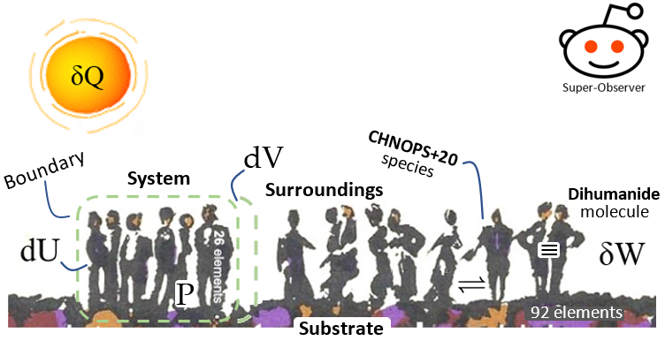
Here, in its most basic first law of thermodynamics definitional view of things, i.e. that defined by Clausius (1865), based on the Carnot engine (1834), itself based on the Papin engine (1690), which presumes that the system in question, typically being water or steam confined to a piston and cylinder, is that whenever an inexact differential unit if heat δQ enters the ‘system’, or social system on our case, defined by an internal energy U, a system pressure P, system temperature T, and system volume V, delineated by shown social boundary, an exact differential change in the internal energy dU will occur, such that the system increases its volume, in accordance with Hooke-Boerhaave law (1675), by the exact differential dV, thereby doing an amount of boundary work, quantified by the inexact differential δW, on the surroundings, the measure of which being formulaically defined as follows:

δW = PdV

In order, therefore, for the human chemical thermodynamicist to begin, in the most basic sense, to quantitatively study any given social system, one needs a gauged instrument to measure the pressure P of the system.
Here, to note, we add in the important caveat that when the system jumps from the basic ‘steam engine’ system model of water molecules expanding and contracting to produce pressure-volume work, to systems wherein chemical reactions accrue, e.g. human chemical reactions actuating in the social system case, then not all of the differential heat input δQ that enters the system will go in total to pressure-volume boundary work; some will go into activating new bond transforming reactions and transformations, e.g. combustion reactions, human reproduction reactions, civil war, etc..
Historically, in 1873, it was German physical chemist August Horstmann, who, building on the work of Clausius, was the first to apply entropy to the problems of chemical dissociation, such as, supposedly, the dissociation of phosphorus pentachloride into phosphorus trichloride and chlorine:

In Oct 1873, Horstmann famously announced the condition for chemical equilibrium to be that of maximum entropy, therein initiating the science of chemical thermodynamics. This condition of ‘maximal entropy’, as erroneously believed in laymanized cultural versions of thermodynamics, does not, to clarify, mean that a state of ‘maximal disorder’ has been reached in the system, but rather that the ‘equivalence value of all uncompensated transformations’, i.e. what we now call ‘entropy increase’, has reached a maximum value.
Our focus herein will not be to broach this immensely entangled problem, as applied to social chemical reactions, but rather to confine our focus to the question of the measurement of pressure in social systems.

Barometer

The invention of a device to measure pressure, historically, originated in what is called the ‘pump problem’, namely the problem associated with the fact that suction pumps in flooded mines, such as shown below right, stopped working once the depth of the height of the water to be raised or the depth of the mine reached about 30 feet, plus or minus about 3 feet:
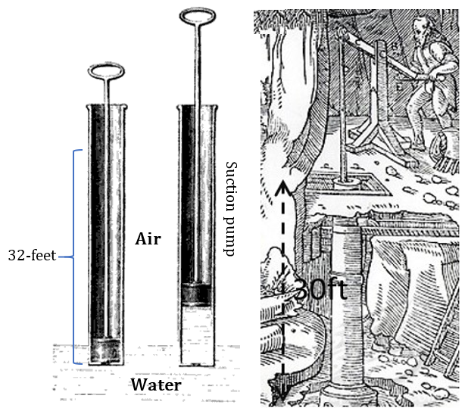
On 27 Jul 1630, the question of the nature of pump problem was put to Galileo by Giovanni Baliani, a physicist and experimenter, who asked him, via letter, why a siphon made to carry water over a hill failed to work if the hill was more than 18 cubits or about 27 feet? Galileo replied that the reason that the pump stopped working at that height was because the column of water was like a rope cord that ‘broke’ when pulled, via the syphon pump, past a certain height; the following is one statement to this view:

“If hemp or steel cords break under excessive weight, what doubt could we have that a cord of water will likewise break? In fact, it will break more easily, insofar as the parts of water, becoming separated from one another, do not have to overcome resistances other than that of the vacuum that is created at the moment of division. This is because in the case of iron and other solids, there is a very strong and tenacious attachment of the parts that is absent in water.”
— Galileo (1630), “Letter to Giovani Baliani”, Aug 6

In 1632, Galileo, after ruminating on this problem further, in his Dialogues Concerning the Two New Sciences, presented his tentative opinions, being a mixture of the water column as a cord argument, but also that abhorrence of the vacuum was a factor as well, and presented the following theoretical vacuum measuring device:
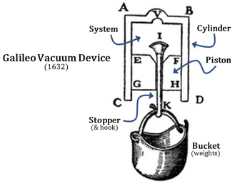
Wherein, ABCD is the cylinder, EFGH is the piston, the space made between the piston and cylinder is the ‘system’, and IK is a sort of adjustable valve and hook, into which, when open, one can add in or take out air or water, which is attached to a weighing bucket. The idea here, according to Galileo, is that one can first invert this device, then pour in an amount of water, then insert the piston and push it down, being sure to let out any extra air via the IK valve, then close the valve by pulling it down so the valve head I fits into its sealing groove, then invert the device. With the device in this water-filled state, one can then add in weights, incrementally, until the water column ‘breaks’, as Galileo saw thing, which according to him would this give a ‘measure’ of the vacuum; in his own words:
“I will tell you how to separate the force of the vacuum from the others, and afterwards how to measure it. For this purpose, let us consider a continuous substance whose parts lack all resistance to separation except that derived from a vacuum, such as is the case with water, a fact fully demonstrated by our Academician in one of his treatises. Whenever a cylinder of water is subjected to a pull and offers a resistance to the separation of its parts this can be attributed to no other cause than the resistance of the vacuum. In order to try such an experiment, I have invented a device [shown above] which I can better explain by means of a sketch than by mere words.”
-- Galileo (1632), Dialogues Concerning the Two New Sciences³

In 1638, Galileo, freed from his inquisition restrictions, to some extents, formerly published his Dialogues, the ideas of which shortly thereafter began to reach the inquisitive scholars of the world.
In Dec 1638, fifty-copies of Dialogues, reached Rome, and were quickly sold out, one copy of which reaching the hands of Gasparo Berti and Rafael Magiotti, who were greatly inspired by the premise of building a vacuum measuring device.
In 1639, or late 1641 (Middleton, 1964), Berti and Magiotti built a sort of ‘expanded’ 35-foot working model of Galileo syphon pump ‘thought experiment’ design, which they attached to the side of Magiotti’s house, as shown below, so to test Galileo’s theories.

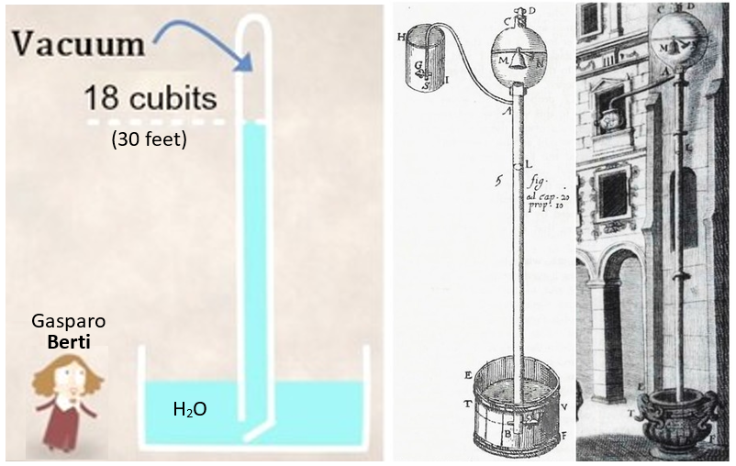

The device, said to have been built by Magiotti, generally based on Galileo’s vacuum measuring thought experiment, basically consisted of along tube, filled tight with water, then sealed by valves at the top and bottom, then placed vertically into a tub of water, shown above. The bottom valve was then opened to see what would happen? What they found was that some of the water, in the tube, fell, or drained out into the tub, stopping when the column was 18 cubits or about 30 feet, depending on conversion method.
Magiotti then passed news of this water column experiment to his friend Italian physicist Evangelist Torricelli, a former student of Galileo.
Torricelli, at this point in time, generally believed that air had weight, that the higher one goes above the surface of the earth, the less air weights or the less force or pressure at that location, and that the weight of the column of water in the Berti experiment was balanced by the pressure of the surrounding atmosphere, such as diagrammed below:
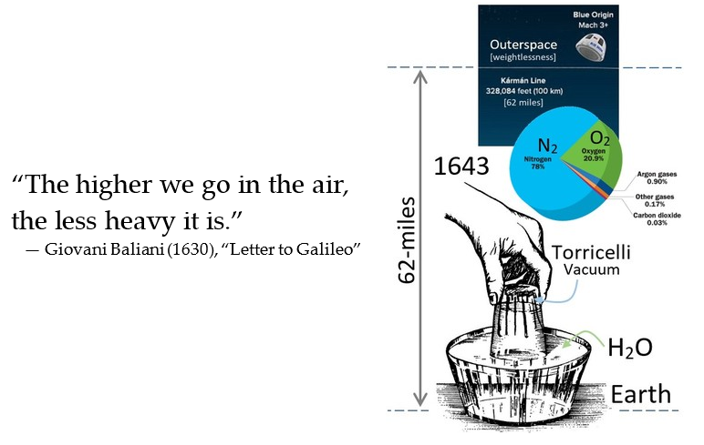
In 1643, Torricelli, working in coordination of Vincenzo Viviani, another former student of Galileo, took it upon themselves to repeat the Berti experiment, albeit done with mercury used in place of water, so to make a more compact version of the Berti water barometer, based on the fact that mercury is 13.5 times denser than water. The idea to use mercury seems to have been either the brainchild of Viviani or Galileo, which is evidence as follows:

“And it is my belief that the same result will follow in other liquids, such as quicksilver, wine, oil, etc., in which the rupture will take place at a lesser or greater height than 18 braccia, according to greater or less specific gravity of these liquids in relation to that of water, reciprocally; always measuring such heights perpendicularly, however.”
— Galileo (1638), corrections made by Vincenzo Viviani, with the approval of Galileo, to the Leiden edition of Dialogues

Whatever the case, Torricelli repeated the Berti experiment using mercury, and therein obtained the mercury barometer, the height of the column being the gauged measurement of the ‘pressure’ of the atmosphere:
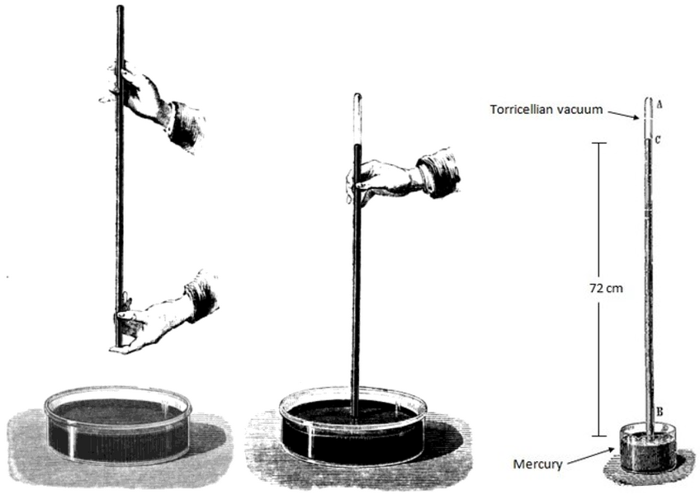

In 1648, Blaise Pascal, after hearing about the Torricelli mercury experiment, from Marin Mersenne, reasoned that if it the results of Torricelli experiment were true, that earth's atmosphere must have a maximum height, and that air pressure on a high mountain must be less than at a lower altitude; his statements on this are as follows:

“I have thought of an experiment which will remove all doubt, if it be executed with exactness. The experiment should be made in vacuo several times, in one day, with the same quicksilver, at the bottom and at the top of the mountain of Puy, which is near our town of Clermont. If, as I anticipate, the height of the quicksilver be less at top than at the base, it will follow that the weight or pressure of the air is the cause of this; there certainly is more air to press at the foot of the mountain than at its summit, while one cannot say that nature abhors a vacuum in one place more than in another.”
— Blaise Pascal (1648), “Letter to Florin Perier”

Pascal reasoned that the barometer mountain climbing experiment could be carried out at the Puy de Dome mountain, which is 4,790 feet (1,460 m) tall, and close to his residence, but his health was poor so he could not climb it.
On 19 Sep 1648, after many months, Pascal convinced Florin Perier, husband of Pascal's elder sister Gilberte, to make the climb; Perier described the results as follows:

“At eight o'clock, we met in the gardens of the Minim Fathers, which has the lowest elevation in town. First, I poured 16 pounds of quicksilver into a vessel, then took several glass tubes, each four feet long and hermetically sealed at one end and opened at the other. Then placed them in the vessel of quicksilver. I found the quicksilver stood at 26" and 3​1⁄2 lines above the quicksilver in the vessel. I repeated the experiment two more times while standing in the same spot. They produced the same result each time. Taking the other tube and a portion of the quicksilver, I walked to the top of Puy-de-Dôme, about 500 fathoms higher than the monastery, where upon experiment, and found that the quicksilver reached a height of only 23" and 2 lines. I repeated the experiment five times with care. Each at different points on the summit, found the same height of quicksilver, in each case.”

This Pascal mountain experiment is diagrammed as follows:

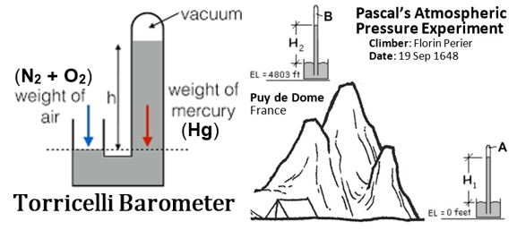
Here, to summarize the observed effect, the mercury (Hg) atoms, in the liquid state, in the column, and the column of air, comprised primarily of nitrogen (N₂) and oxygen (O₂) molecules, both attract towards the large mass of the earth, according to Newtons law of universal gravitation; defined as follows:

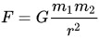
where mass one m₁ is the earth, and mass two m₂ is ether the mass of mercury or of air, depending on attraction in question, r is the radius of separation between the two masses, G is the universal gravitation constant, and F is the force of the gravitation attraction.
In 1738, Daniel Bernoulli, in his Hydrodynamics, building on the above ideas, introduced the now-standard definition of ‘pressure’ as the force per unit area that the particles or molecules of a system exert on the containing walls of the boundary of the system; formulated as follows:

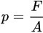
The measure of the ‘force’ applied force normal to the surface, divided by the ‘area’ of the surface, thus defines ‘pressure’, in the modern view of things.

Social Barometer

A diagram of Bernoulli’s model of particles in a piston and cylinder colliding with the container walls with a force per unit area or pressure, is shown below left. Likewise below right, by comparison, is a social system delineated by a social volume, or conceptual piston and cylinder like social boundary, which can be something as simple as boundaries of turfs in troops of chimpanzees or gangs of humans, or something large as the boundary of a country. Pressure, in either case, is defined the same, namely as the average force per unit area, exerted on the walls of the boundary or containing vessel, by the elements, molecules, or chemical species of the system.

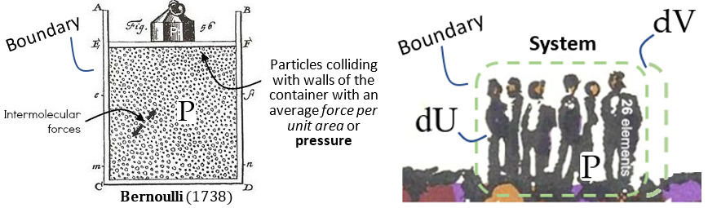

The ‘force’ in question in the Pascal example, Torricelli example, and Berti example is the gravitation force.
The ‘force’ in question in the Bernoulli example are intermolecular forces that arise when weight, shown by weight P, placed above the piston, is added to compress the system, which can become much greater in extent than the force of atmospheric pressure.
The ‘force’ in question in the social system scenario again are intermolecular forces, generally of the electromagnetic variety, which operate between humans in sort of horizontal to the surface of the earth direction, causing attractions, repulsions, and chemical bondings between humans, in a force normal direction to a standing human. In this direction, the following shows the 1950s social gravitation models of Americans physicist John Stewart and economic geographer William Warntz:⁴
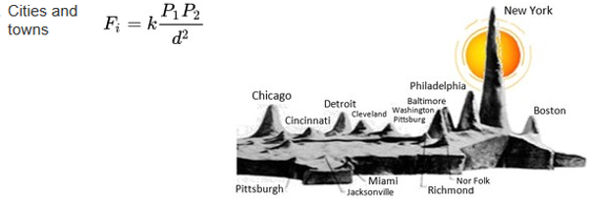
where P₁ and P₂ are populations or social masses of cities, d is the distance of separation between cities, k is a social gravitation constant, and F is the force of attraction between people in each of the two cities in question. Here, New York, in the US, being equivalent to the sun, about which the planets rotate, via gravitational attraction.
In another sense, in respect to social pressure, New York can be considered equivalent to Puy de Dome mountain and how Pascal found that pressure decreased as one climbed the mountain or moved away from the earth. Here, the extrapolation is the prediction that social pressure should decrease as one moves away from a large massive central city, such as New York or Tokyo, and secondly that a human molecular stylized barometric like device can be constructed to measure this ‘social’ pressure, similar to how Pascal measured ‘atmospheric’ pressure.
Historically, while no actual physical models of devices to measure social pressure have been proposed, there have been a few scattered attempts at theoretical outlines in this direction.²
In 1926, Vladimir Vernadsky, a Russian biogeochemist, in his The Biosphere, speaking in semi-coherent thermodynamic language, gave the flowing idea of his view of social pressure:
“Living matter—organisms taken as a whole—is spread over the entire surface of the earth in a manner analogous to a gas; it produces a specific pressure in the surrounding environment, either by avoiding obstacles on its upward path, or overcoming them. The careful observer can witness this movement of life, and even sense its pressure. In the impact of a forest on steppe, or in a mass of lichens moving up from the tundra to stifle a forest, we see the actual movement of solar energy being transformed into the chemical energy of our planet. Cosmic energy determines the pressure of life, which can be regarded as the transmission of solar energy to the earth’s surface. This pressure arises from multiplication, and continually makes itself felt in civilized life. When man removes green vegetation from a region of the earth, he changes the appearance of virgin nature, and must resist the pressure of life, expending energy and performing work equivalent to this pressure.”

In 1945, Stuart Dodd, in his “A Barometer of International Security”, speculated, verbally, about some type of ‘barometer of international tension to detect reliably and early the tensions that lead to war; the gist of this, however, seems to have been some type of opinion polling consortium.
In 1992, Teresa Brennan, an American physics themed relationship theorist, discussed social energy, emphasizing Sigmund Freud’s physical psyche model using the notion of conflicting forces complemented by bound energy and free energy; which she followed up by her 1997 article “Social Pressure”, arguing that social pressure operates as physical energy, arguing that social pressures are pressures to conform but also those exerted on the psyche in the same way that physical pressures are exerted on the body.
In 2005, Ingo Muller, a German physicist, in the Socio-thermodynamics section of his book Energy and Entropy, gave the formulaic interpretation of the external pressures acting on a system of doves surrounded by hawks, where is the external pressure acting on the system, U is the internal energy, V is the volume, and t is time:

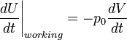

He states “let the ∂V or part of the boundary be moveable under and external pressure”, according to which the above equation represents the change in the energy of the social system as a function of work done by pressures in moving the boundary.
In 2019, the author, in the draft chapters to his Human Chemical Thermodynamics, conceived of a Torricelli conceptualized ‘social barometer’, such that if the weight of mercury was replaced with a given dense liquid-like social mass, originally conceptualized as Americans going into Japan, later conceptualized as social groups like: Quakers, Italians, Jews, etc., or even Thomas Schelling’s 1969 famous checkboard model of racial segregation, etc., these species of people being ones that tend to ‘stick’ to their own kind, in a dense group cohesiveness manner, that lasts over time, were configured into some type of socially-isolated U-shaped system, like the Torricelli barometer, like an experimentally-designed mobile home or double decker bus, as shown below, of some kind, such that only one end of the mercury-like social mass would interact with, be connected or in contact with, or press against the outside air-like social mass, the outer society being akin being here to the weight of the air, then one should find that the size of the social vacuum, created in the closed end of the U-shaped social system, and hence obtain a working social barometer.
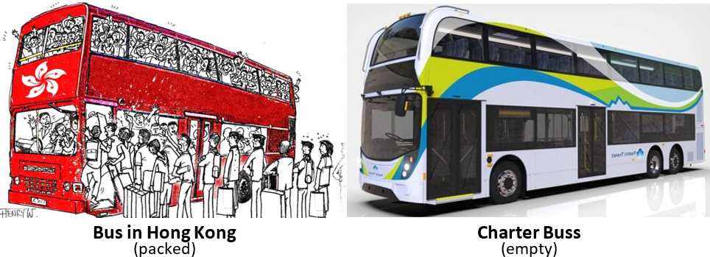
This ‘bus barometer’ concept is elaborated on, in more detail, as follows:
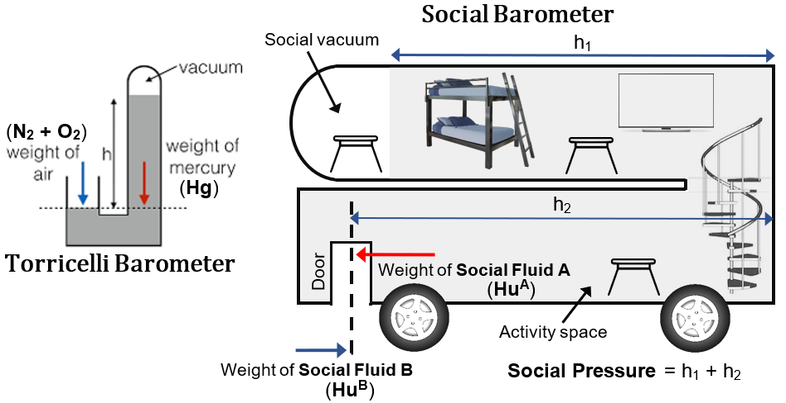
In its most basic conception, to test this social barometer, one would set up a social experiment, akin to the MTV’s famous Real World television series, in which a group of college students were recruited to reside or ‘live’ (exist) on double-decker tour bus / mobile home of sorts, under the ‘overt pretext’ that the goal of the show was to record their goings on, as they visited various cities.
In this manner, the mercury social molecules would be made to cohere, like actual mercury atoms in liquid mercury, per some type of pre-arraigned lucrative financial binding agreement. In the public double-decker scenario, the mercury like social molecules on the packed buss would, invariably be exchanging into and out of the society, which is thus not a true Torricelli barometer.
The bus would be equipped with all the basic amenities of a home, e.g. bed, kitchen, study room, recreation room, tables, seats, etc., arranged in such a way that the far-most back section of the bus, when not occupied with the participants or chemical species, would signify the size of ‘social vacuum’, and the where the activity space, where people are actually found, varying per city, represented by h₁ + h₂ above, would represent the height of the social mercury column or quantitative measure of the social barometer.
One should find, just as predicted by Pascal, that the closed end, i.e. social vacuum space, of the U-shaped social system, would decrease as the U-shaped social system was moved towards New York or Tokyo, meaning the force of the social pressure of these large central cities would work to move more of the mercury-like humans farther up or back into the bus, on average, the big cities being akin to the earth in the Pascal scenario. Secondly, one should find that the size of the social vacuum should increase as one moved away from New York, e.g. towards small towns, with little populations; or equivalently the hypothetical height h of the U-shaped social system would be found to decrease as one climbed away from New York, because there would be less social mass pushing on the mercury like social system.
In another sense, if one were to employ a different experimental design, the size of the ‘social vacuum’ could would be the number of rows of empty seats, or unoccupied social space, in the far back end of the top of bus, or something to this effect. The following, to exemplify, is a photo of an over-packed train in India:

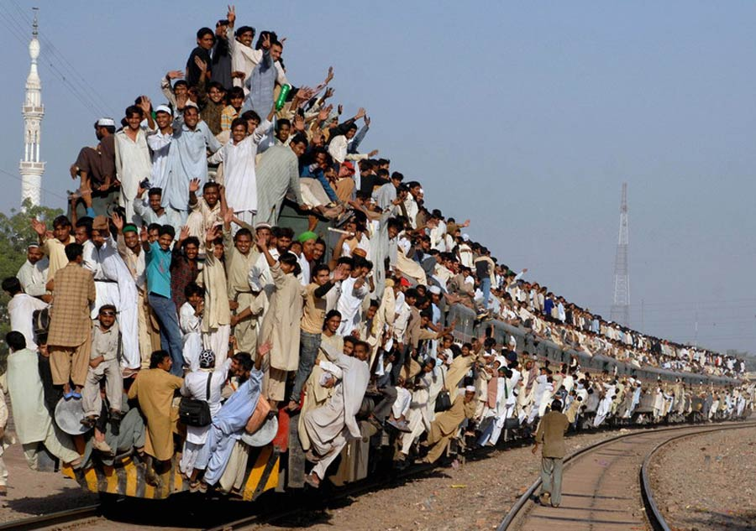

The reason for proposing this tentative conceptual model of a social barometer, to note, is that social thermodynamics instruments are sorely needed in order that the various proposed models can be tested and compared.
“This essay, on the study of energy and society, does not attempt to bring together, evaluate, and select among the growing literature on applying energy models to human society. Almost all, including the present effort, are speculative and somewhat experimental (in the sense of waiting to see if anyone salutes). The state of the art, however, is not appropriate for such an evaluation at this time. The reason is simple. Until models are applied and comparatively ‘tested’ or at least compared, there is no way to evaluate them.”
— Richard Adams (1988), The Eighth Day (pg. 11)

Two related studies, historically speaking, themed in the above proposed sense, are the 1975 Dabbs and Stokes ‘side walk study’, wherein it was found that ‘beauty’ or physical attractiveness effects a measurable volumetric increase in social space, and the 1994 Cohen and Nisbett ‘hallway study’, wherein it was found that neurochemical changes can effect changes in patterns of social space.⁵
In sum, in order to measure ‘work’, socially speaking, in a proper thermodynamic sense, namely PV work or pressure-volume work, as classically diagrammed on a Watt indicator diagram or Carnot cycle graph, one has firstly to have a measure of the change in volume of the social ‘working substance’, i.e. volumetric selection of socially-affined work producing humans, which can be easily obtained, e.g. by measurements of social space, but secondly, and more difficult to obtain, one has to have a gauge to measure ‘pressure’ in a given volume or location of a social system. The above discussion only attempts to outline a crude outline of a potentially workable barometer.
Lastly, however crude the above social barometer model may be, one must remember that nearly all of thermodynamics owes its roots to the crude ‘vacuum measuring device’ of Galileo, with its embedded conceptual errors. Hence, whatever the case, a working of the muscles of the mind on the question of social pressure, is requisite.

Notes
N1. The content of this talk originated as a subsection of the “Galileo Pump Problem” chapter, section: Torricelli Vacuum, of the 2019 draft version of the author’s Human Chemical Thermodynamics, then available online in pdf format, wherein the Torricelli bus experiment was conceived and drafted in the thought experiment idea stage. [1]

References
1. http://www.humanthermodynamics.com/HCT.pdf
2. http://www.eoht.info/page/human+thermodynamic+instrument
3. http://www.eoht.info/page/Galileo+engine
4. http://www.eoht.info/page/Social+gravitation
5. (a) http://www.eoht.info/page/Sidewalk+study
(b) http://www.eoht.info/page/Study

