Proceedings of the IAISAE 2020
International Conference on Thermodynamics 2.0
June 22-24, 2020 | Worcester, MA, USA

ICT2.0:2020-W138

PROPOSED PRINCIPLES OF ECONOMICS: BIOSYMMETRY AND HIERARCHIC SYMMETRY
Garvin H Boyle¹

¹Orrery Software, Richmond, Ontario, Canada

Abstract
Humanity is desperately in need of a new science of economics to emerge and take the lead in resolving our global ecological crises. This will require a significant paradigm shift. All of the laws and principles of this new science may already exist as principles, laws and concepts in the other branches of scientific endeavour. This paper proposes the principle of biosymmetry to create a vision for how that paradigmatic shift can be started. It also proposes the principle of hierarchic symmetry to create a vision for how that paradigmatic shift can be carried forward quickly.
Keywords: principles of science, hierarchy of sciences, symmetry, gauges, universal dynamics

- INTRODUCTION
1.1 Aristotelian philosophy and telos (purpose)
A notable characteristic of the philosophy of Aristotle (384–322 BCE) was his use of apparently purpose-directed outcomes in nature to draw conclusions about the operations of nature. The assumption is that a god-like being has assigned a telos to each object and process. Under this assumption, one could surmise that the telos of an acorn is to become an oak tree. Teleology is the explanation of objects in terms of the telos (the purpose) they appear to embody, and of processes in terms of the telos they appear to demonstrate. The use of arguments based on the concept of telos is called teleological reasoning. Aristotle’s philosophy dominated the educational institutions of Europe until the 16th century birth of the scientific revolution, started by Copernicus [1]. Unfortunately, teleological arguments are highly subject to biases arising from opinions about who (which deity) assigns the telos, and what the most visible outcome is. By developing objective methodologies, subjective and teleological arguments were forcefully set aside by early natural philosophers, and replaced with non-teleological arguments that were consistent with objective empirical evidence. Nevertheless, our daily experience of life in general, and of the economy in particular, continues to be both teleological (i.e. purposeful) and subjective. We wake every morning and make plans and decisions, and carry out those plans throughout the day. So, it should be no surprise to us that the language of modern economic theory is therefore also, perforce, both teleological and subjective. For example, economists concern themselves with mission statements, with business plans and with consumer demands. Business people imagine a telos for themselves, and then strive to make reality conform to their imagination. These are telos-driven concepts.

1.2 The need for an economic science
However, it is now apparent that our modern anthropocentric economic theories are the distal cause of most of the great existential ecological threats that present and future generations must now face. The single-minded focus on the purposes of humankind, to the exclusion of the needs of other people and other species, leads to unexpected and unfortunate side effects. Those economic theories are rooted in the theory of Newtonian equilibrium mechanics of the late 19th century. A great deal of scientific study over the past 70 years has focused on complex adaptive evolving systems that operate far from equilibrium. Economic theory has lagged far behind the advances of the sciences, and has not reformed itself to incorporate these new concepts of dynamic systems. We must urgently strive to establish the study of economics as a fully modern science.

Fig. 1 – Required principles of an economic science
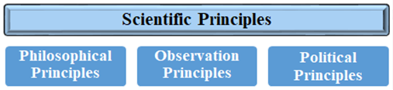

Xi Ji of Peking University has proposed a methodology to establish a science of economics [2]. Such a science must be founded, she argues, on three kinds of scientific principle. Philosophical principles are reasoned assumptions that are, in some sense, axiomatic statements that must be accepted, because they cannot be fully proven true or false. They underlie and are common to all of the sciences. An economic science must share the same set of philosophical assumptions. An example of such a principle is the idea that the laws of physics are invariant under a translation in time. We will return to the implications of that principle shortly. Ferguson provides a very insightful exploration of many such principles [3]. At the other end of the spectrum of scientific principles we find “political principles”. These are the necessary principles that bridge the gap between objective science, and moral behaviour. This gap was a necessary buffer that allowed science to emerge as a discipline of study, and first appeared during the Copernican revolution. These political principles place moral constraints on our economic activities. They are not “discovered” in the same way that philosophical or observational principles might be. They are, by common consent, used as a moral filter to limit our behaviour to ethical norms. We can call them “scientific” only because they must conform to the laws of science. Limitless growth seems to be part of the mantra of modern economic theory, in spite of the impossibility of the idea from the perspective of the sciences. Such a concept must be discarded due to inconsistencies with known scientific theories and empirical data. Political principles of a science of economics are not falsifiable, but they are debatable. They must be consistent with all of the other principles of science. In the middle of Xi’s spectrum of principles we find the observational principles, and this is what we will spend the rest of this paper discussing. These are the principles, or laws, that are discovered by the use of scientific methodologies. They are both debatable and falsifiable.

1.3 The hierarchy of sciences
There are many branches of the study of natural processes. They can be loosely grouped into six categories of scientific enquiry: physics, chemistry, biology, ecology, sociology and economics [4]. Each such category of sciences represents a step upwards in a hierarchy of decreasing generality and increasing complexity. Laws of nature are abstracted at each level.
Fig. 2 – The hierarchy of the sciences
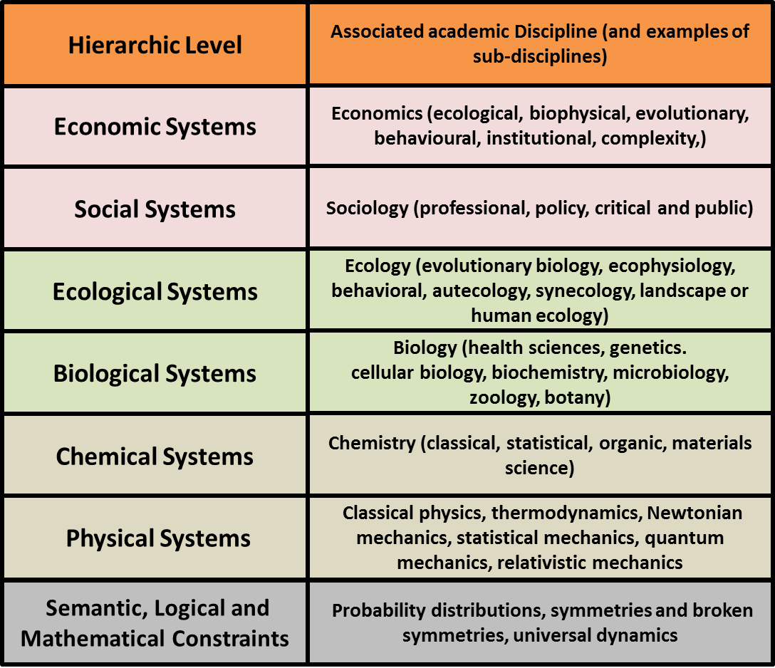
The generality of a science in the lower levels ensures the applicability of its laws at the higher levels. An ecosystem is a kind of very complicated physical, chemical and biological system. No one would argue that the laws of physics, chemistry and biology do not apply to the elements of an ecosystem system. So this ladder of sciences is a nested hierarchy in which laws constraining dynamic processes at one level apply to all higher levels.

1.4 The roles of symmetry, in science and economics
While it is common to imagine that symmetry is a static concept, as in the three-part symmetry of an equilateral triangle, but in fact, it is far more insightful to consider it to be a dynamic concept associated with the changeless aspects of an object or system as time advances. When all else changes, but some aspect remains the same, we have a symmetry. Those aspects that do not change are called the gauge of the symmetry.
In the practice of science, we seek out such symmetries in nature because they provide deep insight into how nature works. The gauge of the symmetry is almost always associated with a conservation law. For example, when Newton published his “Principia” in 1687, the statement that force equals mass times acceleration was true, and if we run a small physics experiment now in 2020, that statement is still as true now as it was then [5]. The invariance of Newtonian mechanics when translated in time leads directly, by Noether’s theorem, to the law of conservation of energy [6]. This foundational principle of virtually all of the sciences is a direct consequence of the assumption about invariance of the Newtonian laws of physics in time.
In the practice of engineering and economics, we create symmetries because they make the economy more efficient and safer. In that context, when all else changes but some things stay the same, we call the symmetry a standard, or a gauge. The gauge of a railroad system is the distance between the rails. If that distance varies, as trains travel along the tracks, they will derail. That is not good. The gauge of a copper wire is the diameter of the wire. If the diameter varies, as current travels along the wire, hot spots will develop and houses will burn. That is not good.
If the previously discovered principles of all of the other sciences are to be the source of insight into discovery of the principles of a science of economics, how best should we extend the laws of those branches of science into economics? We would argue that analogy is a good answer, but symmetry provides a much better answer. We can say an economic system is like an ecosystem, but the concept of likeness is a weak argument. Or, we can say that an economic system is a functional dynamic subsystem of an ecosystem. There is a sameness between the two kinds of system because one is part of the other, constrained by the same fundamental dynamic constraints.

- Principle of biosymmetry
2.1 The problem: anthropocentrism
Most sciences strive to be objective, or unbiased, and an economic science must strive to do the same. However, mainstream economic theory is extremely anthropocentric and subjective. An economic externality is a cost or a profit that accrues to a third party not involved in a transaction – that is, by parties outside of the boundaries of the analysis of the transaction being analyzed. You can think of it as a side-effect of economic transactions. Ecological economic externalities are the non-monetary costs that are born by the ecosystem, such as loss of function due to pollution, or loss of habitat.
Unfortunately, most ecological economic externalities are dismissed from most economic analyses as irrelevant. The costs are born by elements of the biosphere, by people and other organisms, external to the analysis. This has now become an existential issue. Modern economic theory is a distal cause of most of our ecological crises that now threaten the future existence of our species, and of many others.
We need a Copernican-like shift in world view. We need to shift our worldview from anthropocentric desires to bio-symmetric needs. But how do we effect such a shift? In the case of the Copernican revolution, the shift required the dedicated work of many thinkers such as Brahe, Kepler, Galileo and Newton over a period of a century, and the invention of new kinds of mathematics and new ways of thinking. I fear we do not have the luxury of a century of time to fix this problem. I propose this four-step line of thought. First, redefine the word “economy” to mean what it used to mean in the days of the classical economists – a system in which people strive to meet their daily needs – to make their livelihood. Second, borrow the relatively new word “anthroposphere” from the Earth sciences which generally means the scope of effect of the activities of the human species – of the human phenotype. Third, classify the aspects of the anthroposphere into three categories or components: the biotic component (the flesh and bones of the human species), the technosphere (the things humans make), and the noösphere (the instinctive and cognitive behaviours that control what humans do). Fourth, coin a new word that can be applied to all species as a standard description of their experience of existence – the phenosphere. Every species has an associated phenosphere having three components as named above. Fifth, identify a symmetry across the set of all existing species, and call it biosymmetry.

2.2 A statement of the principle
Context: Every species has an economy associated with its phenosphere.
Principle: All of the principles and concepts of an economic science must be consistent from the perspective of all phenospheres.

2.3 The paradigmatic change possible
If we take these ideas seriously, it opens up a number of implications. First, it bridges the gap between the objective sciences and the inevitable subjectivity of economic practices – thereby opening the door for a truly objective economic science to emerge. Economic science could then take its appropriate place at the top of the hierarchy of scientific disciplines. Second, it gives us a different perspective on our role as the senior or dominant species in the biosphere. Under anthropocentrism, we consider this temporal cohort of humans as having proprietary interest in the entirety of the Earth. But under biosymmetry, we should assume trustee responsibilities for the entirety of the Earth on behalf of all species – for both present and future generations. This moves us back towards the world view of those primitive human cultures who knew how to live sustainably on the Earth, unlike the dominant modern human cultures. It gives us deeper insight into the nature of wealth, and the effects of a single-minded pursuit of increased wealth in a finite Earth. It converts the focus of the economic mandate from financial matters to matters of existence and persistence of our species on this Earth. Third, it also gives us a different perspective on our own daily economic activities. Economic externalities become wealth transfers. Ecosystem services become economic appropriations. Economic rents for abiotic resources become international, interspecies, and intergenerational debts. A marginal financial focus becomes an existential biophysical focus.

- PRINCIPLE OF HIERARCHIC SYMMETRY
3.1 The problem: emergent research question
We do not have time to wait for this new science to slowly emerge, nor must we. It is no surprise that all of the pieces of this new science have already been forged, and merely need to be identified, refitted, and joined together. If, consistent with the arguments of Cohen and Stewart, economic science becomes the top branch of scientific endeavor in the hierarchy of sciences [4]. Then all of the principles of science discovered so far can be extended into economics, just as physical laws extend into chemistry, and chemical laws extend into biology. But, how do we logically extend all of the accepted observational principles of the sciences up into a science of economics? Under what circumstances does a law discovered in a lower level of the hierarchy of sciences become instantiated and useful at a higher level? It is here proposed that the philosophical means by which the laws of science can be extended upward through the hierarchy is not by analogy, but by symmetry. An economy is not just like an ecosystem. An economy is a dominant emergent sub-system of an ecosystem – a subsystem that has emerged many times in many ways, and which is subject to evolutionary forces. An economy is an ecosystem in bloom.

3.2 A statement of the principle
Context: Such an economic science would be the top-most branch of scientific enquiry in the hierarchy of scientific disciplines, and as such it studies the innermost system of a set of logically nested systems.
Principle: All of the dynamic constraints that emerge in any type of system located at a lower level in the hierarchy constrain the dynamics of all types of system located at a higher level in the hierarchy.

3.3 Of universalities and frameworks
Over the past seventy years there has been an increasing interest in the study of systems of all kinds in many varied circumstances, and a new interdisciplinary branch of study of “systems science” has emerged [7]. As part of this rising interest, many dynamic patterns of behaviour have been observed upon as appearing in many otherwise non-related systems. These dynamic patterns have come to be referred to as universal dynamics. It is noted that for many of these phenomena the claim to universality is grand if unqualified, but the concept offers great promise. One can organize all such phenomena identified so far as “universal” into a framework that looks like this:

Fig 3: Framework of Universal Dynamics
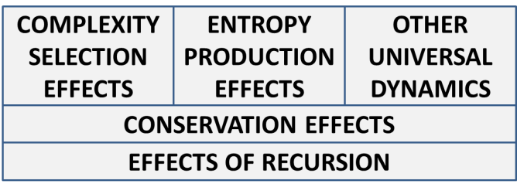
Each of the boxes in this framework contains dynamics that can be described by their effects.
Effects of recursion: Low-entropy micro-complexities emerge from time to time as low-probability accidents of continuous fluctuations of either regular or random timing.
Conservation effects: Symmetries prevent the emergence of most imaginable kinds of micro-complexities, but also prevent the subsidence of some micro-complexities that previously successfully emerged, thereby establishing a platform on which other micro-complexities can, in their own time, emerge as accidents of recursive processes.
Complexity selection effects: Evolutionary processes select some micro-complexities for preservation, allowing them to accumulate into more complex low-entropy structures and processes.
Entropy production effects: Entropy production processes continually degrade and disassemble complex low-entropy structures and processes.
Effects of other universal dynamics: Many other universal dynamics constrain and add context and variety to this ongoing endless re-invention of complex adaptive evolving systems.
We see in this diagram at least two instances of dynamics operating in opposition to each other. Random recursion is operating in opposition to conservation effects, but together they form semi-stable platforms of low-entropy structures and processes. Complexity selection and entropy production, at a higher level, accumulate and disassemble more complex structures and processes. The associated activity of the other universal dynamics is yet to be determined.

- CONCLUSION
Humanity is desperately in need of a new science of economics to emerge and take the lead in resolving our global ecological crises. This will require a significant paradigm shift. All of the laws and principles of this new science may already exist as principles, laws and concepts in the other branches of scientific endeavour. This paper proposes that the principle of biosymmetry creates a vision for how that paradigmatic shift can be started. It also proposes that the principle of hierarchic symmetry creates a vision for how that paradigmatic shift can be carried forward quickly.

REFERENCES

[1] Nicolaus Copernicus, On the Revolutions of the Celestial Spheres, 1543.
[2] Xi Ji, Ecological economics in China: from origins, to inertia, to rejuvenation. In Costanza, R., J.D. Erickson, J. Farley, and I. Kubiszewski (editors). Sustainable Wellbeing Futures: A Research and Action Agenda for Ecological Economics. Edward Elgar Publishing, Cheltenham: 61-89.
[3] K. Ferguson, The Fire in the Equations: Science, Religion, and the Search for God, Templeton Press, 2004.
[4] J. Cohen, I. Stewart, The Collapse of Chaos: Discovering Simplicity in a Complex World, 1994.
[5] Isaac Newton, Philosophiae Naturalis Principia Mathematica, 1687.
[6] E. Noether, Nachrichten von der Gesellschaft der Wissenschaften zu Göttingen, Mathematisch-Physikalische Klasse, 1918.
[7] G. E. Mobus, M. C. Kalton, Principles of Systems Science, Springer complexity, 2015.

